10

The motor in the first circuit is on. For each of the other circuits, tick one box () to show if the motor is on or off.

a. b
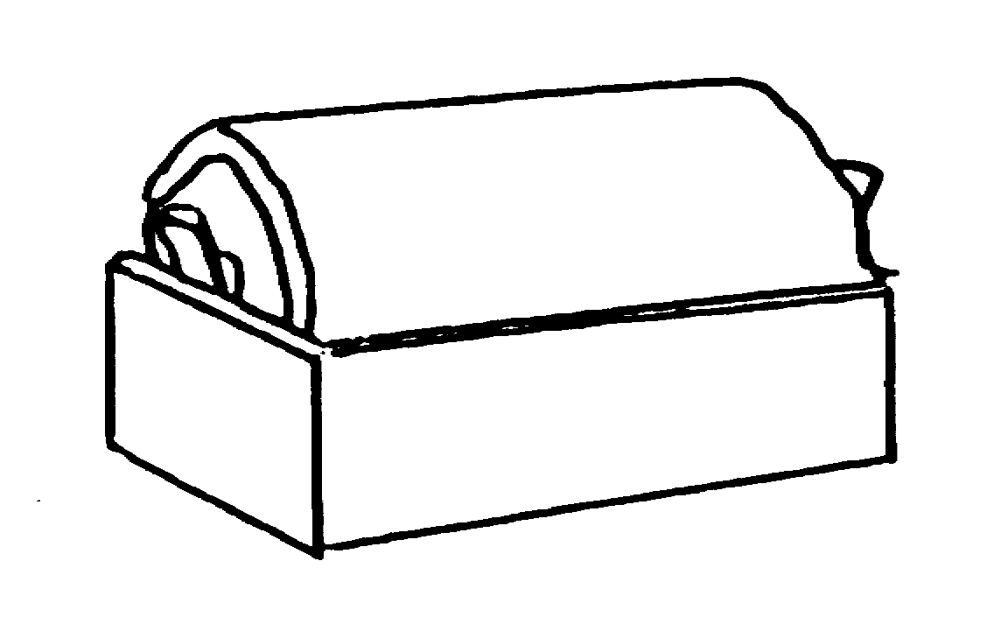
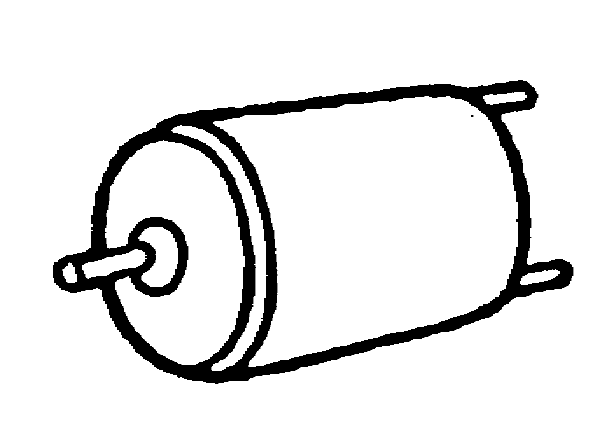
.

off
on
.

off
on
3

c. d.

.

off
on
.

off
on

e.

.

off
on

